

#### **June 4, 5, 6, 2021**

**REMEMBERING THE BRAVE FOUNDATION**

**&**

**The Colorado Rifle Club**

**present the**

**13th Annual Midwestern Armed Forces Memorial Match &**

**NRA High Power & Mid Range Regional Championships**

**Honoring**

**2ndLt James Cathey ~ LCpl Gregory Rund ~ LCpl Justin Ellsworth**

**1stLt Matthew Vandegrift ~ SSG Christopher Falkel**

**LCpl Nicklas Palmer ~ Detective Michael Thomas ~ LCpl Andrew Riedel**

**HM3 Christopher “Doc” Anderson ~ GM2 Danny Dietz ~ SSgt Sam Holder**

**LCpl Kyle Burns ~ LCpl Tommy Slocum ~ PFC Jesse Givens**

**SSG Justin Vasquez ~ SFC Kenneth Westbrook & SGT Marshall Westbrook**

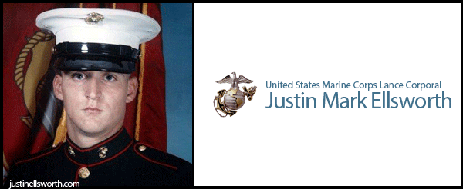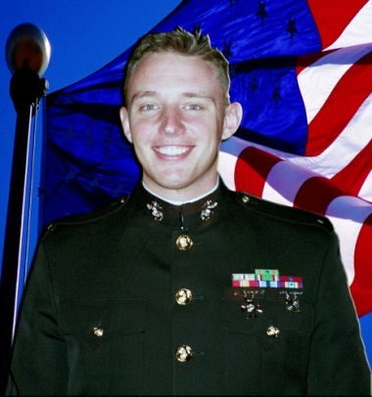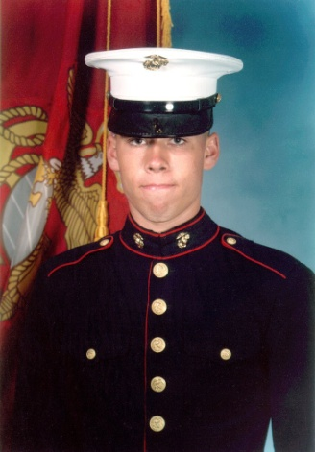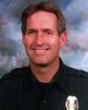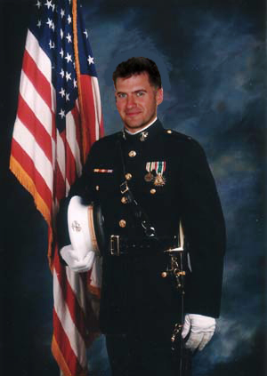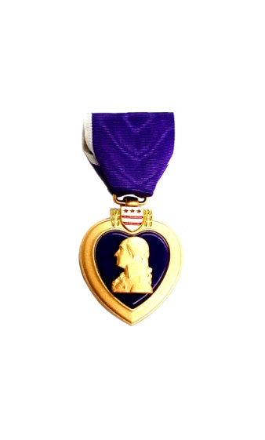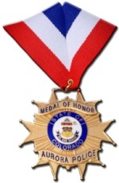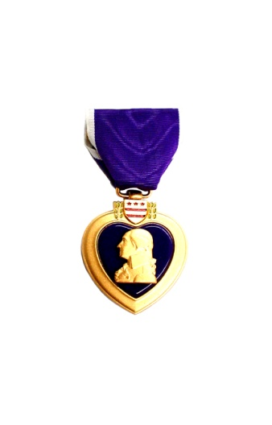

**Same rifle type must be fired in all matches within an aggregate to be eligible to win in the ATC Matches**

**NRA**

**HIGH POWER REGIONAL CHAMP**

**IONSHI P**

**Friday 4 June 2021 (07:00 Show / Stats open at 06:30)**

**Agent Michael Thomas Memorial Trophy Match**

**200S, 200R, 300R, 600S**

Overall ATC Aggregate Match (Matches 1, 2, 3, & 4)

**\*NRA High Power Championship\***

**7**

**1stLt Matthew Vandegrift Memorial Trophy Match**

600 yrd SR, MR

2 Sighters /20 rnds for record in 20min

**4**

**2ndLt James Cathey Memorial Trophy Match**

200 yrd SR, MR

2 Sighters /20 rnds for record in 20min

**1**

**LCpl Justin Ellsworth Memorial Trophy Match**

300 yrd SR, MR

2 Sighters ~ Prone Position

2 Rapid Fire Strings w/Mag Change (2x8 SR, 5x5 MR)

70 Sec per String

**3**

**LCpl Greg Rund Memorial Trophy Match**

200 yrd SR, MR

2 Sighters ~ Sitting Position

2 Rapid Fire Strings w/Mag Change (2x8 SR, 5x5 MR)

60 Sec per String

**2**

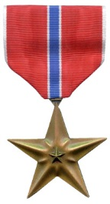

**Some of the families of these American Heroes will be there to present the Memorial**

**Trophies and plaques to the competitors and to enjoy the day with everyone there. Please come out to meet them, thank them, and honor their son’s memories.**

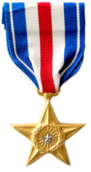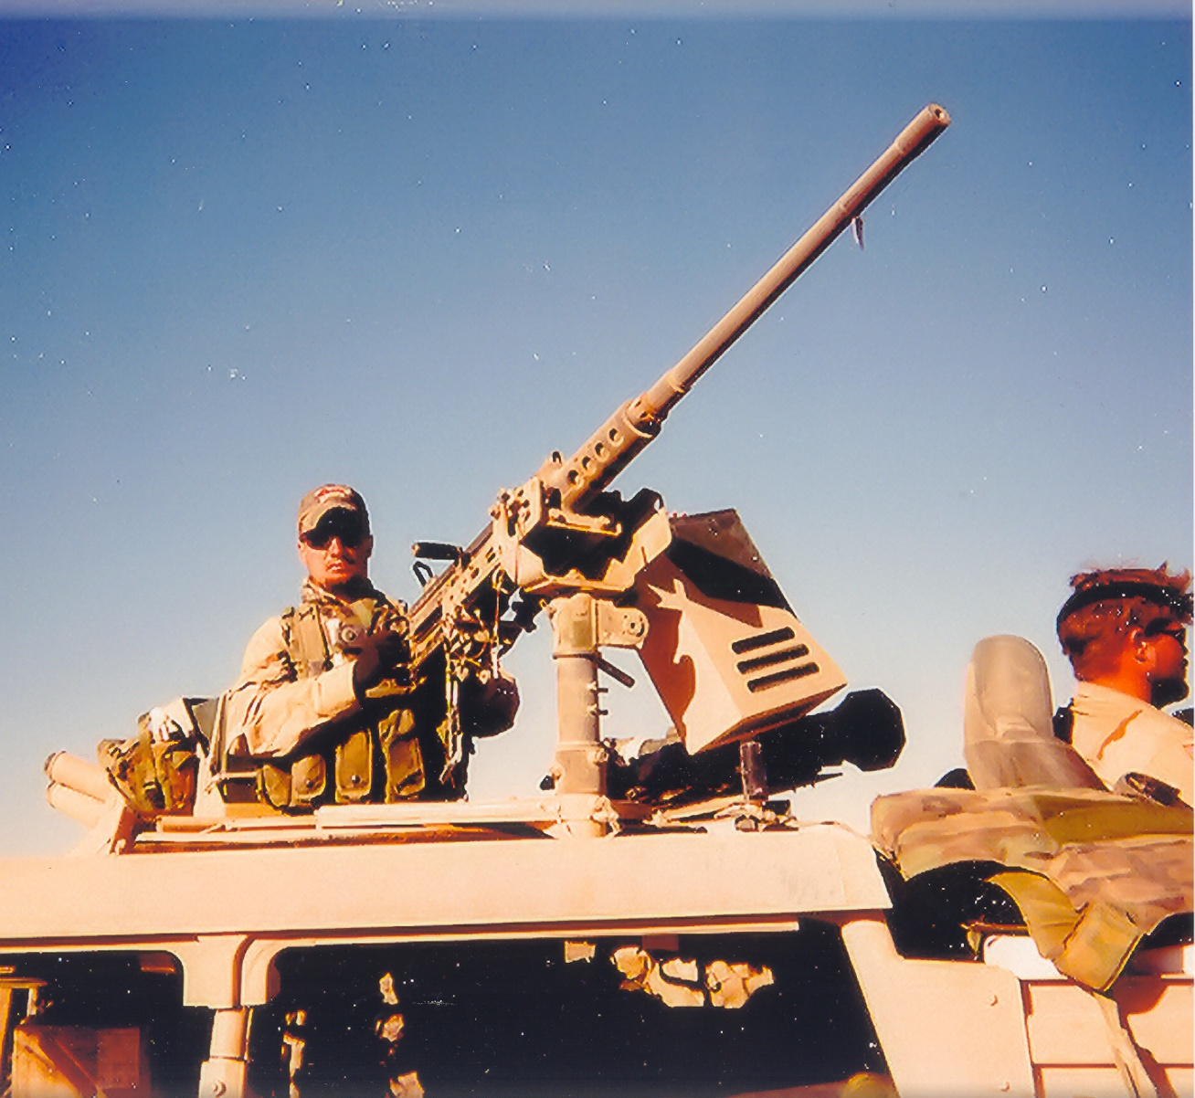

**LCpl Nicklas Palmer Memorial Trophy Match**

200S, 600S

Slow Fire Aggregate Match (Matches 1 & 4)

**SSG Christopher Falkel Memorial Trophy Match**

200R, 300R

Rapid Fire Aggregate Match (Matches 2 & 3)

**6**

**5**

**LCpl Nicklas Palmer**

**U S Marine**

**SSG Chris**

**Falkel**

**U S**

**Army**

**Detective Michael Thomas**

**U S**

**Air Force**

**ANG**

**1stLt Matthew Vandegrift**

**U S**

**Marine**

**LCpl Justin Ellsworth**

**U S Marine**

**LCpl Greg Rund**

**U S Marine**

**2ndLt James Cathey**

**U S Marine**

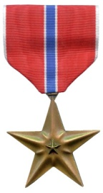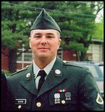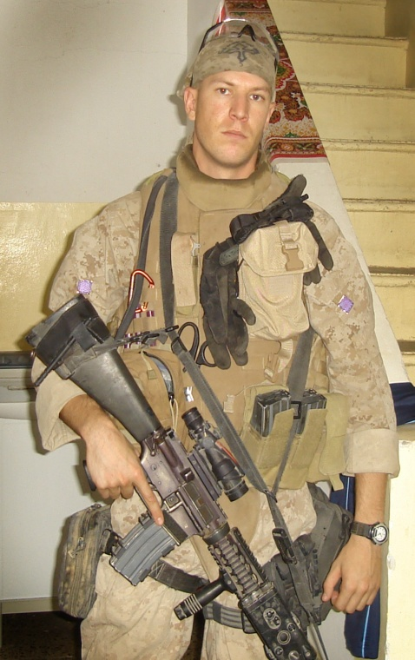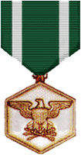1_device_v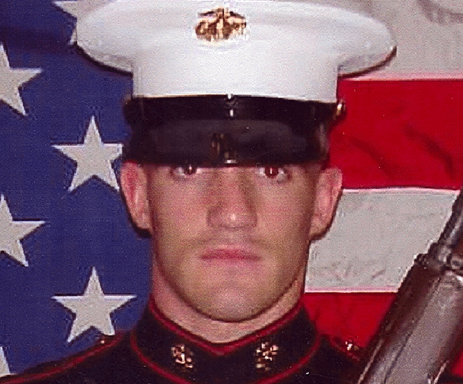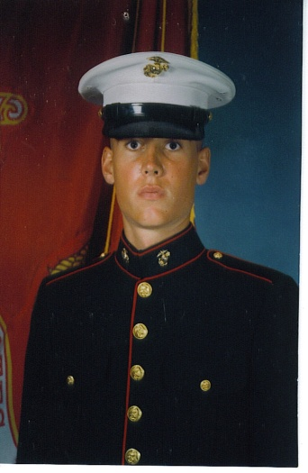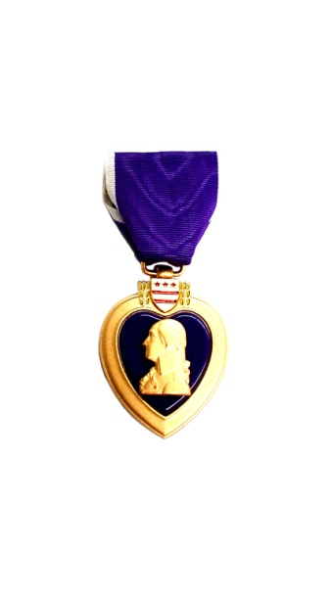

**Saturday 5 June 2021 (07:00 Show / Stats open at 06:30)**

**Sunday 6 June 2021 (07:00 Show / Stats open at 06:30)**

**15**

**14**

**13**

**12**

**11**

**10**

**9**

**8**

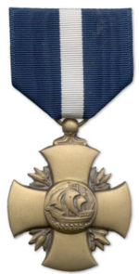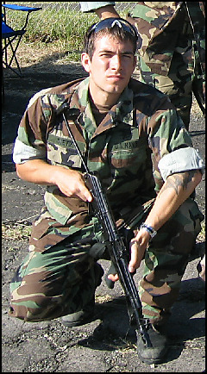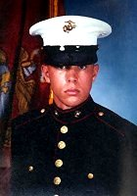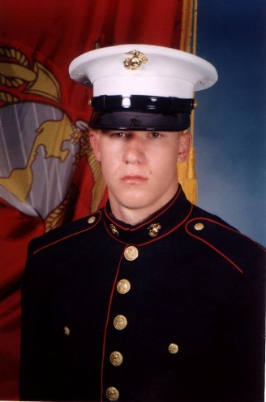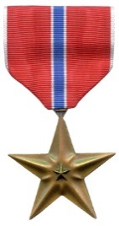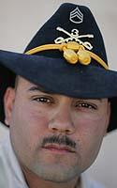

**LCpl Tommy Slocum Memorial Trophy Match**

600 yrd Service Rifle

Unlimited Sighters /20 rnds for record in 25 min

(All may shoot but only Service Rifle competitors can win)

(Individual scores from this match count toward the NRA Mid Range Regional Championship)

**LCpl Kyle Burns Memorial Trophy Match**

600 yrd Any Rifle/Iron Sights

Unlimited Sighters /20 rnds for record in 25 min

(All may shoot but only Iron Sight Rifle competitors can win)

(Individual scores from this match count toward the NRA Mid Range Regional Championship)

**HM3 Christopher Anderson Memorial Team Trophy Match**

600 yrd Service Rifle

Unlimited Sighters /20 rnds for record in 25 min

(All may shoot but only Service Rifle Teams can win)

(Individual scores from this match count toward the NRA Mid Range Regional Championship)

**LCpl Andrew Riedel Memorial Team Trophy Match**

600 yrd Police, Military & Veteran only Match Any Rifle/Any Sight

Unlimited Sighters/20 rnds for record in 25 min

(All may shoot but only police/military/veteran competitors can win)

(Individual scores from this match count toward the NRA Mid Range Regional Championship)

**SSGT Justin Vasquez**

**US**

**Army**

**PFC Jesse Givens**

**US**

**Army**

**GM 2 Danny Dietz**

**U S Navy SEAL**

**HM3**

**Christopher**

**“Doc” Anderson**

**U S Navy Corpsman**

**LCpl Andrew Riedel**

**U S Marine**

**LCpl Tommy Slocum**

U S Marine

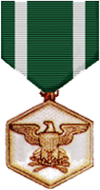

**SSgt**

**Sam Holder**

**U S Marine**

**LCpl Kyle Burns**

**U S Marine**



**GM2 Danny Dietz Memorial Team Trophy Match**

1000 yrd Any Rifle/Any Sight

Unlimited Sighters /20 rnds for record in 30 min

**SSGT Justin Vasquez Memorial Trophy Match**

600 & 1000 yrd Prone

Overall Match Rifle Aggregate Match

**PFC Jesse Givens Memorial Trophy Match**

600 & 1000 yrd Prone

Overall Service Rifle Aggregate Match

**SSgt Sam Holder Memorial Trophy Match**

600 yrd Any Rifle/Any Sight

Unlimited Sighters/20 rnds for record in 25 min

(Individual scores from this match count toward the NRA Mid Range Regional Championship)

**NRA**

**MID RANGE**

**REGIONAL**

**CHAMPIONSHI P**

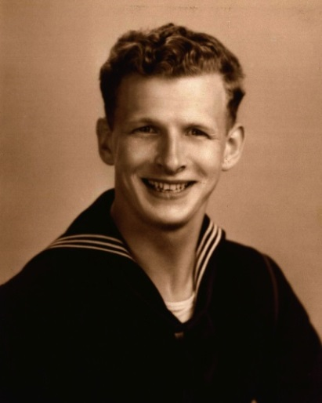

**SSGT Justin Vasquez**

**US**

**Army**

**Machinist Mate 2nd Class Conrad Grims Trophy Match**

NRA Mid Range Regional Championship

This trophy is a lifetime achievement award trophy match. Conrad will be there to fire the match and to present the trophy that bears his name!

**16**

**United States Navy World War II (1943 ~ 1947)**

**17 Colorado Stallion Grand Aggregate Trophy Match**

Overall Grand Aggregate of Matches (1, 2, 3, 4, 8, 9, 10, 11, 12, 13)

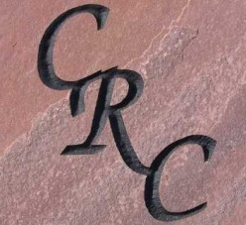

**13th Annual Midwestern Armed Forces Memorial Match**

**June 4, 5, 6, 2021**

**LIABILITY RELEASE FORM MUST BE ON FILE OR SIGNED BY ALL CONTESTANTS AT THE MATCH**

**FIRST NAME: \_\_\_\_\_\_\_\_\_\_\_\_\_\_\_\_\_\_\_\_\_\_\_\_\_\_\_\_\_\_\_\_\_\_ LAST NAME:\_\_\_\_\_\_\_\_\_\_\_\_\_\_\_\_\_\_\_\_\_\_\_\_\_\_\_\_\_\_\_\_\_**

**STREET ADDRESS: \_\_\_\_\_\_\_\_\_\_\_\_\_\_\_\_\_\_\_\_\_\_\_\_\_\_\_\_\_\_\_\_\_\_\_\_\_\_\_\_\_\_\_\_\_\_\_\_\_\_\_\_\_\_\_\_\_\_\_\_\_\_\_\_\_\_\_\_\_\_\_\_\_\_\_**

**CITY: \_\_\_\_\_\_\_\_\_\_\_\_\_\_\_\_\_\_\_\_\_\_\_\_\_\_\_\_\_\_\_\_\_\_\_\_\_\_\_\_\_\_\_ STATE:\_\_\_\_\_\_\_\_\_\_\_\_\_ ZIP:\_\_\_\_\_\_\_\_\_\_\_\_\_\_\_\_\_\_\_**

**DAY PHONE: \_\_\_\_\_\_\_\_\_\_\_\_\_\_\_\_\_\_\_\_\_\_\_\_\_\_\_\_\_\_ EVENING PHONE: \_\_\_\_\_\_\_\_\_\_\_\_\_\_\_\_\_\_\_\_\_\_\_\_\_\_\_\_\_\_\_\_**

**EMAIL ADDRESS: \_\_\_\_\_\_\_\_\_\_\_\_\_\_\_\_\_\_\_\_\_\_\_\_\_\_\_\_\_\_\_\_\_\_\_NRA NUMBER: \_\_\_\_\_\_\_\_\_\_\_\_\_\_\_\_\_\_\_\_\_\_\_\_\_\_\_\_\_\_\_\_\_**

**NRA HP CLASS: HIGH MASTER, MASTER, EXPERT, SHARPSHOOTER, MARKSMAN, UNCLASS**

**NRA MR CLASS: HIGH MASTER, MASTER, EXPERT, SHARPSHOOTER, MARKSMAN, UNCLASS**

**NRA LR CLASS: HIGH MASTER, MASTER, EXPERT, SHARPSHOOTER, MARKSMAN, UNCLASS**

**CIRCLE ONE IF APPLICABLE: MILITARY / VETERAN / POLICE / CIVILIAN**

**MATCH REVIEW**

**Open practice Thursday 3 June 2021—Muster at 1,000 yrd line 10:00!**

**Friday 4 June 2021 - NRA High Power Regional Championship Match**

**(Stats open at 06:30—Check in at 07:00 at Range House and then proceed to the 200 Yard Line)**

**2ndLt James Cathey Memorial Trophy Match**

**MATCH 1** 200 yrd - 2 Sighters/ 20 rnds for record in 20 min

 Circle the type of rifle you are firing for this match: Service Rifle Match Rifle Tactical Rifle

**LCpl Greg Rund Memorial Trophy Match**

**MATCH 2** 200 yrd - 2 Sighters/ 2 strings of rapid fire in 60 sec/string

 Circle the type of rifle you are firing for this match: Service Rifle Match Rifle Tactical Rifle

**LCpl Justin Ellsworth Memorial Trophy Match**

**MATCH 3** 300 yrd - 2 Sighters/ 2 strings of rapid fire in 70 sec/string

Circle the type of rifle you are firing for this match: Service Rifle Match Rifle Tactical Rifle

**1stLt Matthew Vandegrift Memorial Trophy Match**

**MATCH 4** 600 yrd - 2 Sighters/ 20 rnds for record in 20 min

 Circle the type of rifle you are firing for this match: Ser Rifle Match Rifle Tact Rifle F-O F-TR

**AGGREGATE MATCHES**

**SFC Kenneth Westbrook & SGT Marshall Westbrook Memorial Trophy Match**

**MATCH 18** 200S, 200R Aggregate Match

**(Aggregate of Match 1 and Match 2)**

**LCpl Nicklas Palmer Memorial Trophy Match**

**MATCH 5** 200S, 600S Slow Fire Aggregate Match

**(Aggregate of Match 1 and Match 4)**

**SSGT Christopher Falkel Memorial Trophy Match**

**MATCH 6** 200R, 300R Rapid Fire Aggregate Match

**(Aggregate of Match 2 and Match 3)**

**Agent Michael Thomas Memorial Trophy Match**

**MATCH 7** 200S, 200R, 300R, 600S Overall ATC Aggregate Match

**(Aggregate of Match 1, 2, 3, & 4)**

**AWARDS CEREMONY FOR DAY 1 WILL BE HELD AT THE END OF ATC MATCH**

**Saturday 5 June 2021 - NRA Mid Range Regional Championship Match**

**(Stats open at 06:30—Check in at 07:00 at Range House and then proceed directly to the 600 Yard Line)**

**SSgt Sam Holder Memorial Trophy Match**

**MATCH 8** 600 yrd — Unlimited Sighters/20 rnds for record in 25 min

 Circle the type of rifle you are firing for this match: Ser Rifle Match Rifle Tact Rifle F-O F-TR

**LCpl Kyle Burns Memorial Trophy Match**

**MATCH 9** 600 yrd — Unlimited Sighters/20 rnds for record in 25 min

 Circle the type of rifle you are firing for this match: Ser Rifle Match Rifle Tact Rifle F-O F-TR

**LCpl Tommy Slocum Memorial Trophy Match**

**MATCH 10** 600 yrd — Unlimited Sighters/20 rnds for record in 25 min

 Circle the type of rifle you are firing for this match: Ser Rifle Match Rifle Tact Rifle F-O F-TR

**Sunday 6 June 2021 - NRA Mid Range Regional Championship Match Continued**

**(Stats open at 06:30—Check in at 07:00 at Range House and then proceed directly to the 600 Yard Line)**

**LCpl Andrew Riedel Memorial Team Trophy Match**

**MATCH 11** 600 yrd — Unlimited Sighters/20 rnds for record in 25 min Any Rifle/Any Sight

 Circle the type of rifle you are firing for this match: Ser Rifle Match Rifle Tact Rifle F-O F-TR

(All may fire but, must be Military/Veteran/Police to be eligible for this trophy)

**HM3 “Doc” Anderson Memorial Team Trophy Match**

**MATCH 12** 600 yrd — Unlimited Sighters/20 rnds for record in 25 min Service Rifle

(All may fire, but to be eligible for this trophy, competitor must fire Service rifle in this match )

 Circle the type of rifle you are firing for this match: Ser Rifle Match Rifle Tact Rifle F-O F-TR

**GM2 Danny Dietz Memorial Team Trophy Match**

**MATCH 13** 1,000 yrd — Unlimited Sighters/20 rnds for record in 30 min

 Circle the type of rifle you are firing for this match: Ser Rifle Match Rifle Tact Rifle F-O F-TR

**PFC Jesse Givens Memorial Trophy Match**

**MATCH 14** Service Rifle Aggregate Match

**(Aggregate of Service Rifle Scores from Matches 8, 9, 10, 11, 12, 13)**

**SSGT Justin Vasquez Memorial Trophy Match**

**MATCH 15** Service Rifle **/** Match Rifle / F-Class Aggregate Match

**(Aggregate of Match Rifle Scores from Matches 8, 9, 10, 11, 12, 13)**

**Machinist Mate 2nd Class Conrad Grims Trophy Match**

**MATCH 16** NRA Mid Range Regional Championship

**Colorado Stallion Trophy Match**

**MATCH 17** Service Rifle **/** Match Rifle / F-Class Aggregate Match

**Grand Aggregate of Matches 1, 2, 3, 4, 8, 9, 10, 11, 12, 13)**

**CONTRIBUTIONS TO REMEMBERING THE BRAVE**

**Match contributions for ATC Match - $50.00**

**Match contribution for all 600 Yard Individual Matches together - $60.00**

**Team Match contribution of $100.00 per Team ($25.00 PER SHOOTER) should be made at the match, so please wait until the match so we can focus on getting the team compositions exactly how you expect them.**

**(PICK-UP TEAMS ARE AUTHORIZED AND ENCOURAGED, TRY NOT TO MIX TEAMS IN TERMS OF RIFLE TYPES AS IT COULD MAKE YOU INELIGIBLE FOR CERTAIN TROPHIES)**

**MAKE YOUR CONTRIBUTION PAYABLE TO:**

**REMEMBERING THE BRAVE**

**MAIL ENTRIES & CHECKS to Arrive No Later Than June 1, 2021 to:**

**Frank Stratton**

**5389 Coors Street**

**Arvada, CO 80002**

**TOTAL for all individual ATC and individual MR matches = $110.00 (Not including the Team Matches as indicated above.)**

**TEAM MATCH CONTRIBUTIONS MADE AT THE MATCH.**

**ACTIVE/RESERVE MILITARY TEAMS MAY USE THE METHOD MOST SUITABLE TO THEIR ORGANIZATIONS**

**\* Mid Range Regional Championship Match is a composite match comprised of the competitor’s individual scores from Matches (8, 9, 10, 11, & 12) so it is important to know that to be competitive for this match, you should fire all these matches.**

**Visit the CRC website for more information. www.crci.org**

**For unanswered questions, to volunteer for the match or to make other queries:**

**Contact Frank Stratton at: 303-947-5505 stratton2885@gmail.com**